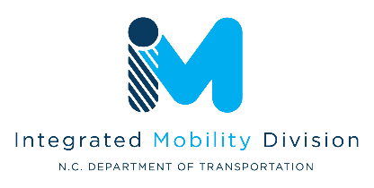
NCDOT-IMD Transportation Demand Management (TDM) Quarterly Progress Report – FY27

This progress report form is required for your TDM program’s quarterly progress reporting.

Organization/Agency Name:
Click or tap here to enter text.

Reporting Period:
Options: Q1 (July 1 - Sept. 30), Q2 (Oct. 1 - Dec. 31), Q3 (Jan. 1 - March 31), Q4 (April 1 - June 30)
Click or tap here to enter text.

Program Updates

Program Organizational Changes
Document any changes to the personnel that support the TDM programming or changes in job function or role in the TDM program.
Click or tap here to enter text.

Issues/Concerns
If the scope or associated timelines from the annual workplan have changed, address the changes and reasons here. Also address any needs from NCDOT.
Click or tap here to enter text.

Plans for Next Quarter
What is your organization planning to accomplish next quarter?
Click or tap here to enter text.

Reporting

Outreach and Engagement Overview
Presentations (in-person or virtual)  (List examples) | Number of Events: | Number of Attendees:
- [List examples]

Tabling Events  (List examples) | Number of Events: | Number of People Engaged:
- [List examples]

Other (examples - travel training event, vanpool formation meeting, etc.)  (List examples) | Number of Events: | Number of Attendees/ People Engaged:
- [List examples]

Vanpool Program (if applicable)
Number of active vanpools
(report number as of the last day of the reporting quarter)

Highlights
Grantees are encouraged to submit examples of any work accomplished such as marketing materials, event photos, tools, planning documents, etc. as attachments to your quarterly reporting.
You may also use the space below to provide any written highlights including any quotes or stories that demonstrate how the grant funded efforts impacted communities and individuals.
Click or tap here to enter text.

Work Plan Accomplishments
This section should address accomplishments as compared to the workplan. Responses should also highlight any success, challenges, or lessons learned, as applicable.

[Modified work plan for each organization will be inserted here to include space for providing updates on individual work plan items.]

